**St John the Evangelist**

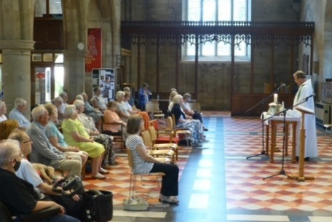**Midweek Community**

**Programme**

**Jan-Apr 2025**





*Church open from 10am*

*Service starts at 10.30am*

**Theme 1: Grace**

**Jan 8** **The Baptism of Christ** Lk 3:15-17, 21-22

Revd. Rob Latham

**Jan 15**  **What is Grace?**  Eph 2:8-10

Revd. Pam Stote; talk: Denise Coomber

**Jan 22 The Prodigal Son** Lk 15:11-32

Revd. Andrew Attwood

**Jan 29 Peter** Jn 13:31-38;

Revd Pam StoteJn 21:15-18

**Feb 5 The woman taken in adultery** Jn 8:1-11Revd. Neswyn Firth; talk: Jane Mullaney

**Feb 12 Justified by Grace** Rom 3:21-26

Revd. Rob Latham

**Feb 19 Joseph** Gen 50:19-21

Revd. Mary Rai

**Feb 26 Naomi** Ruth 1:1-5, 8-14;

Revd. Neswyn Firth Ruth 4:13-17

**Mar 5 Ash Wednesday** Luke 4:1-13

Revd. Andrew Attwood

**Theme 2: Words from the Cross**

**Mar 12 Invitation to forgiveness – *Father forgive them***

Revd. Mary Rai; talk: Jane Mullaney Lk 23:32-38; Eph 4:29-32

**Mar 19 Invitation to Service – *I am thirsty***

Revd. Rob Latham Jn 19:28-30

**Mar 26 Invitation to Hope – *Today you’ll be with me in Paradise***

Revd. Pam Stote Lk 23:39-43; 2 Cor 1:3-7

**Apr 2 Invitation to Adoption – *Here is your son, here is your mother***

Revd. Neswyn Firth Jn 1:1, 6-14; Jn 19:25-7

**Apr 9 Invitation to Empathy–*My God, why have you forsaken me?***

Revd. Pam Stote; talk: Denise Coomber Ps 22: 1-15; Mk 15:33-6

**Apr 16 Invitation to Trust – *Father, into your hands I commit my spirit***

Revd. Andrew Attwood Lk 23:44-9; Ps 31:1-5

**Apr 23 Invitation to Commit - *‘It is finished’*** Lk 12:50; Jn 19:28-30

Revd. Mary Rai

**Apr 30 Resurrection Witnesses**

Revd. Rob Latham 1 Cor 15:1-11

**Who We Are**

We come together to worship God and make friends of all ages.

God shows his love for us in Jesus and by the Holy Spirit.

We worship using Common Worship format and sing hymns familiar to most but sometimes we enjoy learning a less well known one.

We remain seated throughout until a time of greeting one another and fellowship at the end of the service.

Having received God’s love, we go out to share the love of Jesus with those we meet.

Find out more from:

Catherine Pennington

07717 053774 [catherineroberts49@gmail.com](mailto:catherineroberts49@gmail.com)

David Hewitt

859798 [davidhewit@gmail.com](mailto:davidhewit@gmail.com)

Alison Lucas

858563 [alys8519@yahoo.com](mailto:alys8519@yahoo.com)

Pam Stote

07708 231882 [pamstote49@gmail.com](mailto:pamstote49@gmail.com)

Denise Coomber

07734 489835 denisekcoomber@aol.com