Forthcoming events
19th October – Church Ceilidh
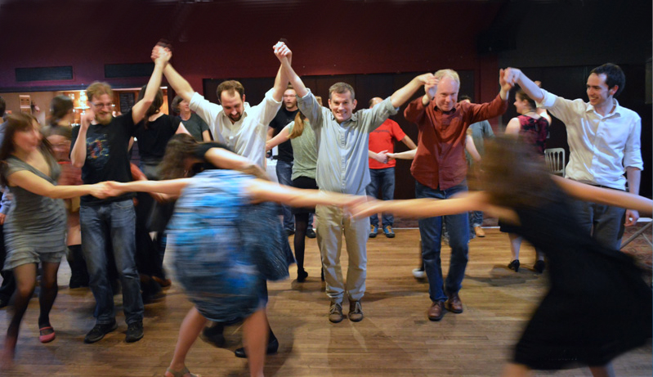

6th November – Talking Jesus Roadshow
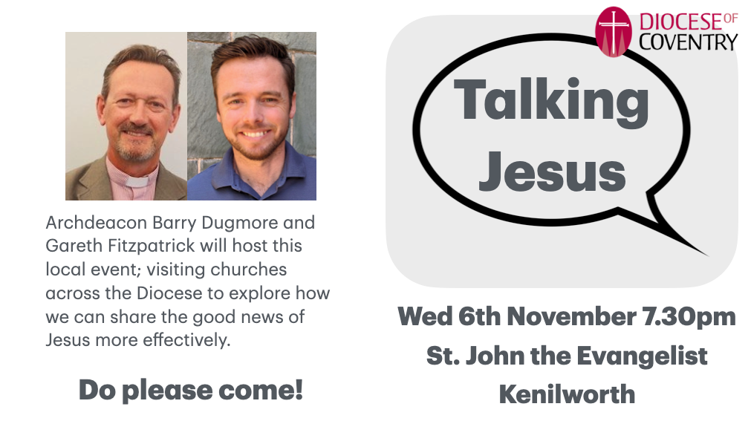
8th & 9th November – Learning Community 5

