**St John the Evangelist**

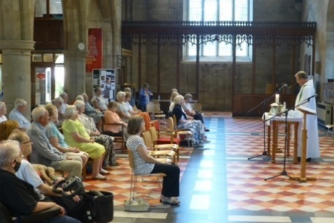**Midweek Community**

**Programme**

**May-Aug 2025**



*Church open from 10am*

*Service starts at 10.30am*

**Theme 1: Gifts of the Spirit**

**May 7** **Creativity** Ex 31: 1-11

Revd. Rob Latham; talk: Denise Coomber

**May 14**  **Encouragement**  2 Tim 1:1-5, 3:10-17   
Revd. Mary Rai; talk: Jane Mullaney

**May 21 Prophecy** 1 Cor 14:1-5

Revd. Andrew Attwood

**May 28 Giving** Rom 12:1-8;

Revd Neswyn FirthMatt 6:1-4

**Jun 4 Tongues** 1 Cor 14:6-18Revd. Mary Rai

**Jun 11 Power…to be sent out (Pentecost)** Acts 1:1-8, 2:1-4

Revd. Andrew Attwood

**Theme 2: Called…Sent**

**Jun 18 Gideon** Judges 6:11-16

Revd. Rob Latham; talk: Denise Coomber

**June 25 Hannah & Samuel** 1 Sam 1:1-3, 9-11, 20

Revd. Neswyn Firth 1 Sam 3:1-11

**Jul 2 Jesus** Lk 4:13-30; Phil 2:2-11

Revd. Rob Latham

**Theme 2: Called….Sent**

**Jul 9 Mary mother of Jesus** Lk 1:26-38

Revd. Mary Rai; talk: Jane Mullaney

**Jul 16 Paul and Barnabas** Acts 13:1-5, 32-3, 42-3

Revd. Neswyn Firth

**Jul 23 Jeremiah** Jer 1:4-10

Revd. Andrew Attwood

**Jul 30 72 disciples** Lk 10:1-24

Revd. Rob Latham

**Aug 6 Ananias** Acts 9:10-19

Revd. Rob Latham; talk: Denise Coomber

**Aug 13 Woman at the well** Jn 4:4-26

Revd. Andrew Attwood

**Aug 20 Moses**Num 16:39-50

Revd. Mary Rai

**Aug 27 Isaiah** Is 6:1-13

Revd. Rob Latham

*During the summer you will have the chance to choose your favourite hymn and tell us what it means to you.*

**Who We Are**

We come together to worship God and make friends of all ages.

God shows his love for us in Jesus and by the Holy Spirit.

We worship using Common Worship format and sing hymns familiar to most but sometimes we enjoy learning a less well known one.

We remain seated throughout until a time of greeting one another and fellowship at the end of the service.

Having received God’s love, we go out to share the love of Jesus with those we meet.

Find out more from:

Catherine Pennington

07717 053774 [catherineroberts49@gmail.com](mailto:catherineroberts49@gmail.com)

David Hewitt

859798 [davidhewit@gmail.com](mailto:davidhewit@gmail.com)

Alison Lucas

858563 [alys8519@yahoo.com](mailto:alys8519@yahoo.com)

Pam Stote

07708 231882 [pamstote49@gmail.com](mailto:pamstote49@gmail.com)

Denise Coomber

07734 489835 denisekcoomber@aol.com