**St John the Evangelist**

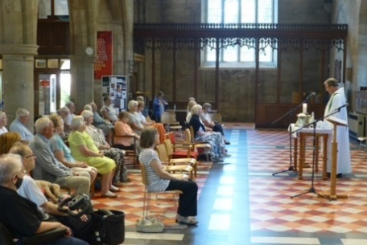**Midweek Community**

**Programme**

**Sept-Dec 2024**



*Church open from 10am*

*Service starts at 10.30am*

**Theme 1: Lessons In Faith**

**Sept 4** **Raising of Lazarus** Jn 11:1-4, 32-44

Revd. Pam Stote

**Sept 11**  **Faith that walks**  Gen 12:1-5

Revd. Andrew Attwood

**Sept 18 Faith that believes** Gen 15:1-6

Revd. Mary Rai

**Sept 25 Faith that laughs** Gen 21:1-7

Revd. Rob Latham

**Oct 2 Harvest** Ps 148; Ruth 2:1-12; Revd. Neswyn Firth Lk 12:16-21

**Oct 9 Faith that gives** Gen 22:1-19

Revd. Pam Stote

**Oct 16 Faith that endures** Rom 4:18-25

Revd. Mary Rai; talk: Jane Mullaney

**Oct 23 Faith that inherits** Gal 3:26-4:7

Revd. Andrew Attwood

**Oct 30 Faith that loves** Philemon 8-18

Revd. Pam Stote; talk: Denise Coomber

**Nov 6 For all the Saints** Matt 5:1-12

Revd. Neswyn Firth; talk: David Hewitt

**Theme 2: Waiting!**

**Nov 13 Need for patience** 2 Pet 3:3-15a

Revd. Rob Latham James 5:7,8,10, 11

**Nov 20 Continuing to trust** Lam 3:22-27

Revd. Mary Rai; talk: Jane Mullaney Rom 8:18-25

**Nov 27 Ready and waiting** Luke 12:35-40

Revd. Neswyn Firth Matt 25:1-13

**Dec 4 Expecting the best** Phil 3:20-21

Revd. Andrew Attwood Rev 21:1-5

**Dec 11 Grasping the moment**  Acts 8:30-39

Revd. Pam Stote; talk: Denise Coomber

**Dec 18 Carol service**

Revd. Mary Rai

**Dec 25 Christmas Day service at 10am**

**Who We Are**

We come together to worship God and make friends of all ages.

God shows his love for us in Jesus and by the Holy Spirit.

We worship using Common Worship format and sing hymns familiar to most but sometimes we enjoy learning a less well known one.

We remain seated throughout until a time of greeting one another and fellowship at the end of the service.

Having received God’s love, we go out to share the love of Jesus with those we meet.

Find out more from:

Catherine Pennington

07717 053774 [catherineroberts49@gmail.com](mailto:catherineroberts49@gmail.com)

David Hewitt

859798 [davidhewit@gmail.com](mailto:davidhewit@gmail.com)

Alison Lucas

858563 [alys8519@yahoo.com](mailto:alys8519@yahoo.com)

Pam Stote

07708 231882 pamstote49@gmail.com